AI ASSIGNMENT – 9.4
NAME:PENNA BHARGAVI
2303A52391
BATCH:44
Task 1: Auto-Generating Function Documentation in a SharedCodebase
Task Description:
You are given a Python script containing multiple functions without any docstrings.

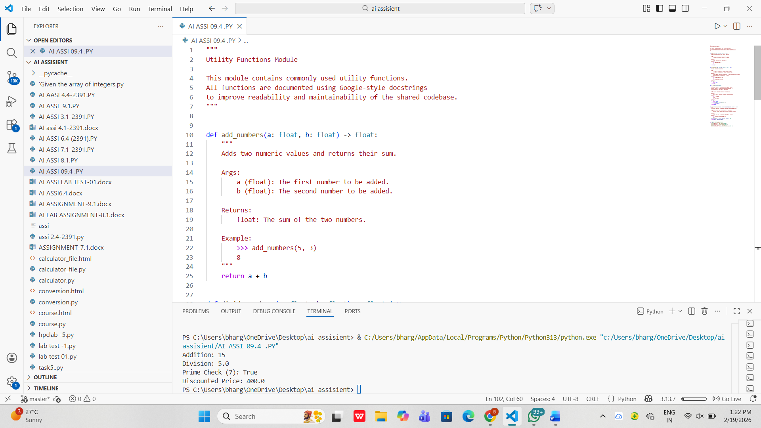

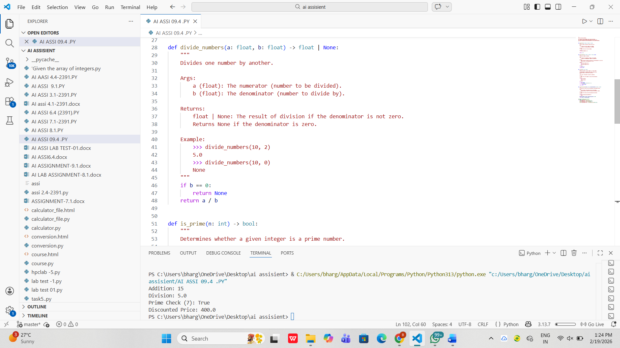

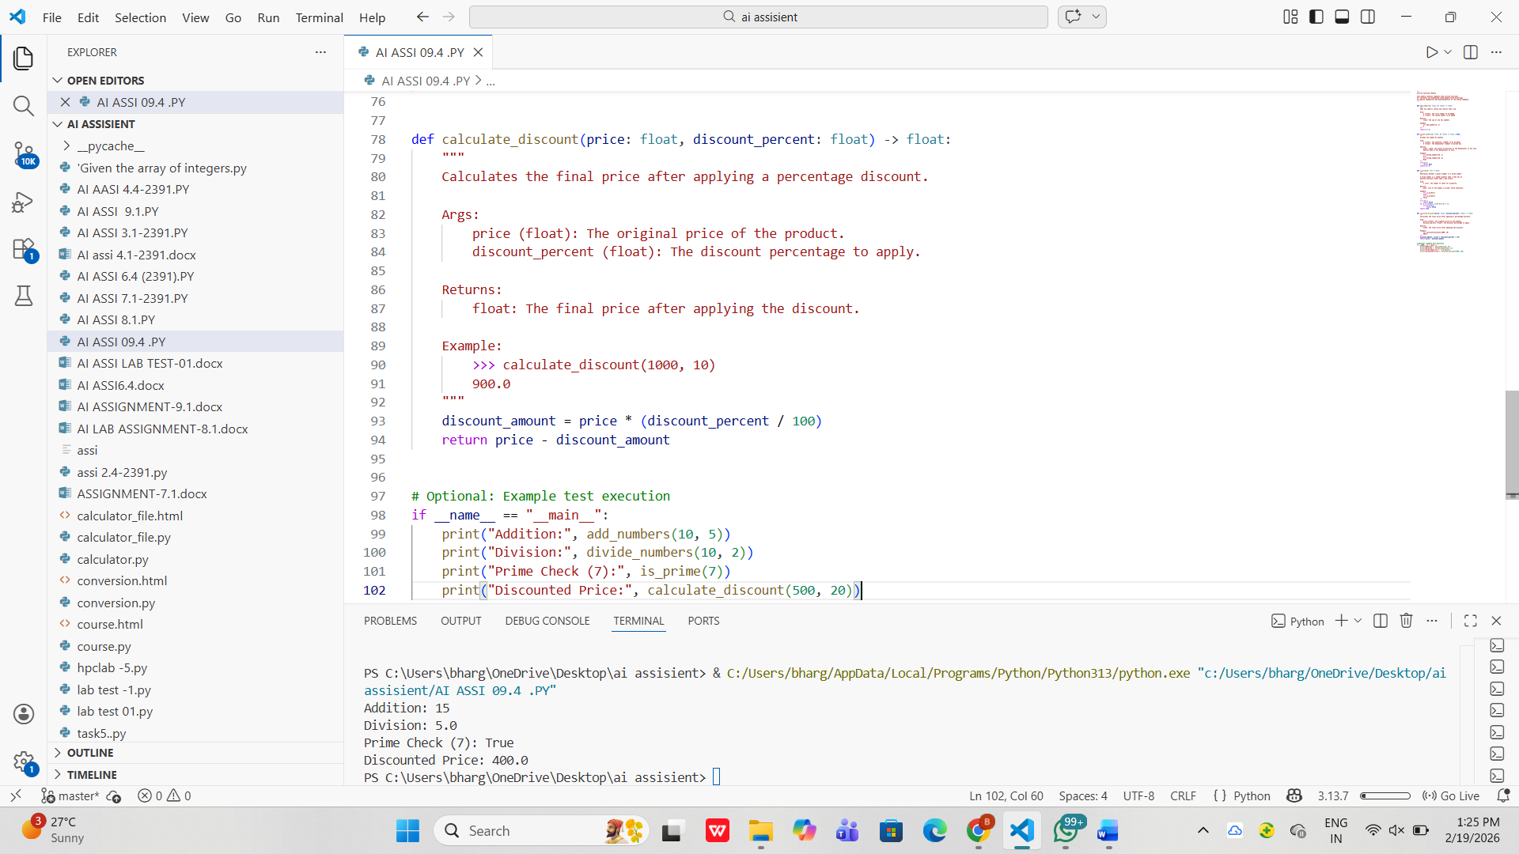

Task 2: Enhancing Readability Through AI-Generated InlineComments
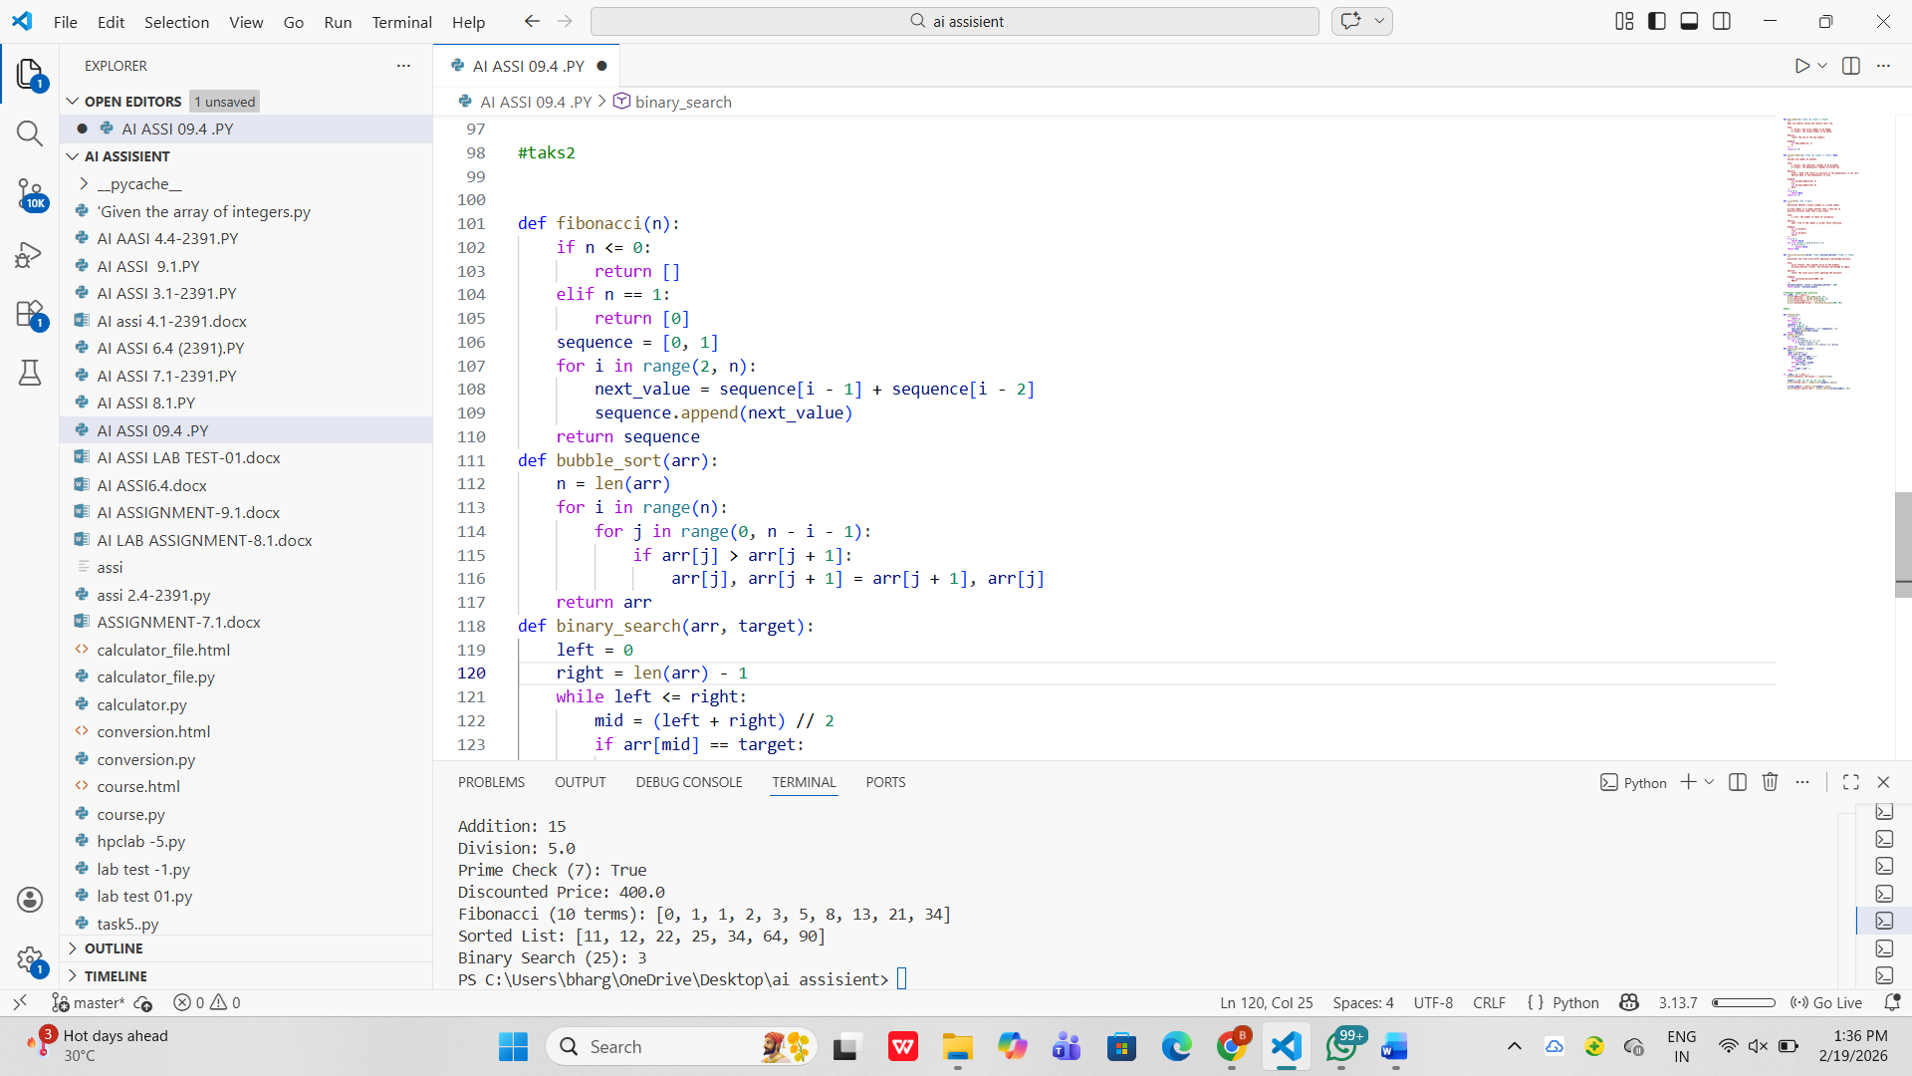
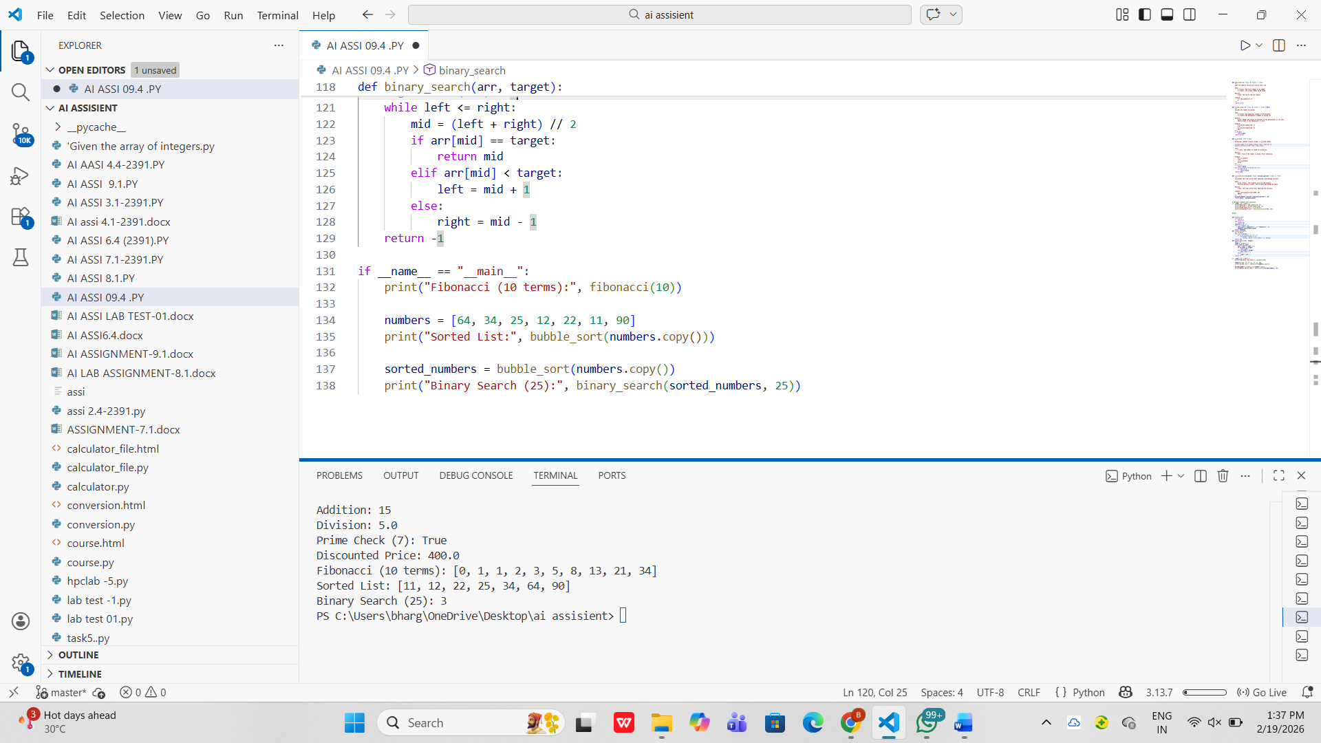

Task 3: Generating Module-Level Documentation for a Python Package
Task Description:
Provide a complete Python module to an AI tool and instruct it to
automatically generate a module-level docstring at the top of the file
that includes:

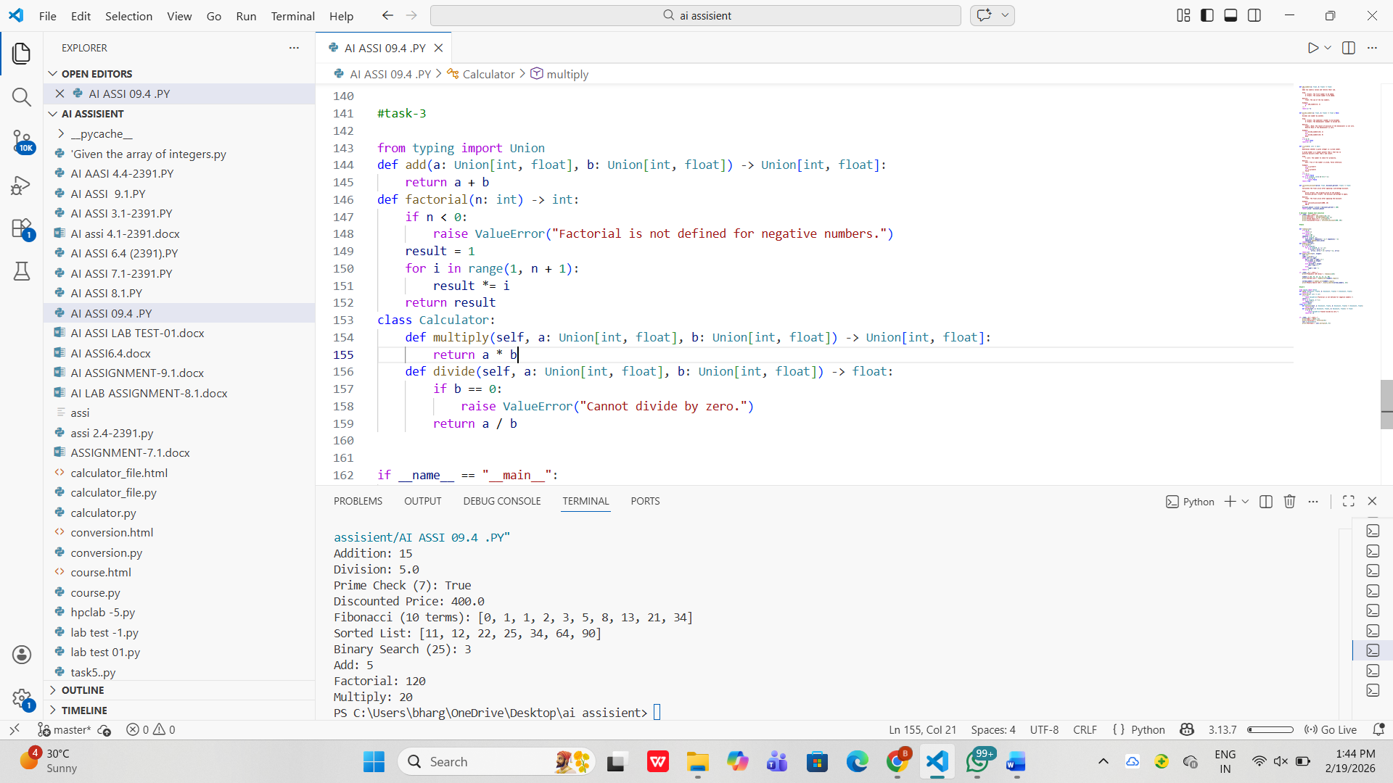
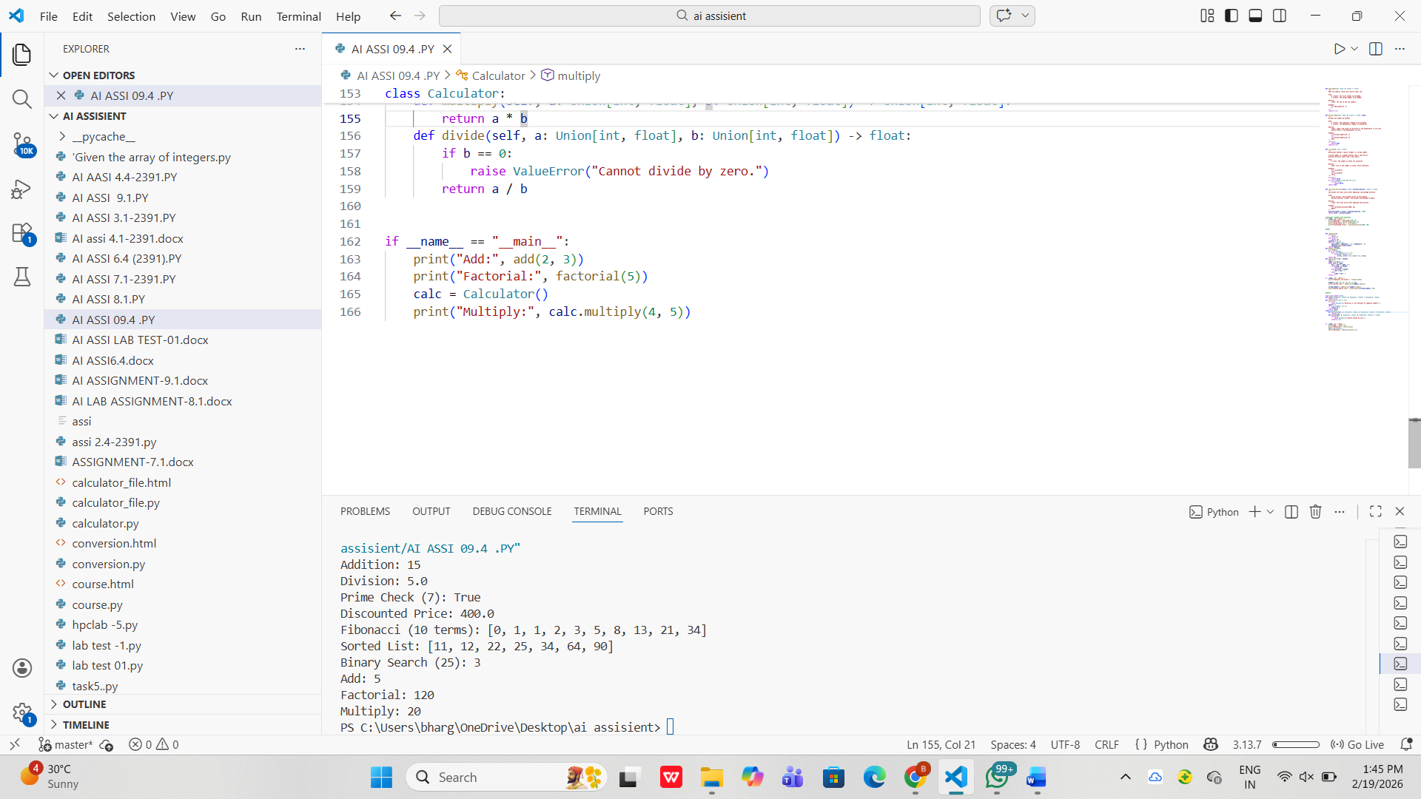

Task 4: Converting Developer Comments into Structured Docstrings
Task DescriptionYou are given a Python script where functions contain detailed inlinecomments explaining their logic.
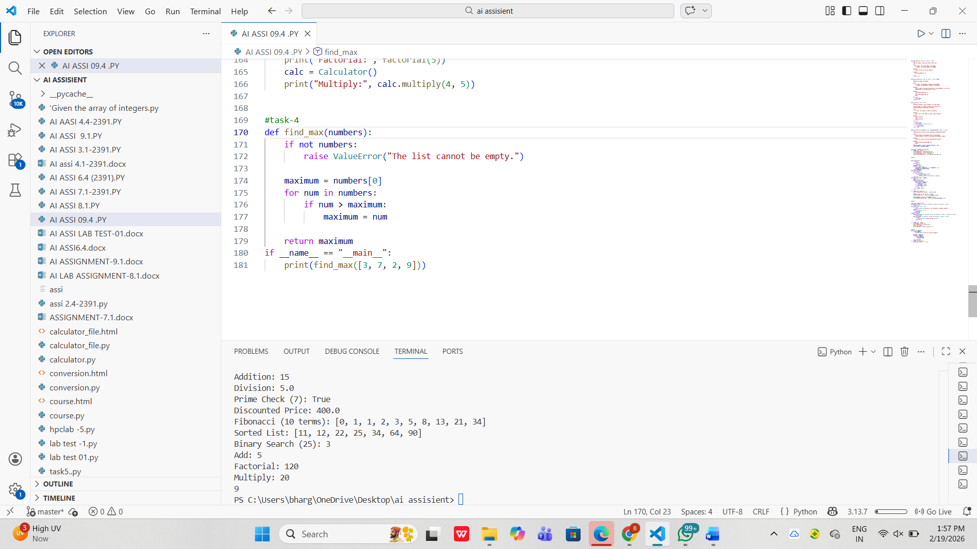
Task 5: Building a Mini Automatic Documentation Generator

